|  |  |
| --- | --- |
| Activity | Data Type |
| Number of beatings from Wife | Discreate data |
| Results of rolling a dice | Discreate data |
| Weight of a person | Continuous data |
| Weight of Gold | Continuous data |
| Distance between two places | Continuous data |
| Length of a leaf | Continuous data |
| Dog's weight | Continuous data |
| Blue Color | Discreate data |
| Number of kids | Discreate data |
| Number of tickets in Indian railways | Discreate data |
| Number of times married | Discreate data |
| Gender (Male or Female) | Discreate data |

Q1) Identify the Data type for the Following:

Q2) Identify the Data types, which were among the following

Nominal, Ordinal, Interval, Ratio.

|  |  |
| --- | --- |
| Data | Data Type |
| Gender | Nominal |
| High School Class Ranking | Nominal |
| Celsius Temperature | Interval |
| Weight | Ratio |
| Hair Color | Ratio |
| Socioeconomic Status | Interval |
| Fahrenheit Temperature | Interval |
| Height | Ratio |
| Type of living accommodation | Ordinal |
| Level of Agreement | Interval |
| IQ(Intelligence Scale) | Interval |
| Sales Figures | Interval |
| Blood Group | Ratio |
| Time Of Day | Interval |
| Time on a Clock with Hands | Interval |
| Number of Children | Interval |
| Religious Preference | Ratio |
| Barometer Pressure | Interval |
| SAT Scores | Ratio |
| Years of Education | Nominal |

Q3) Three Coins are tossed, find the probability that two heads and one tail are obtained?

Answer= Coins=3

Two Head and one tail;

P ( H T H )

P ( H H T )

P (T H H )

= 1/8 + 1/8 + 1/8

=3/8

Q4) Two Dice are rolled, find the probability that sum is

1. Equal to 1
2. Less than or equal to 4
3. Sum is divisible by 2 and 3

Ans=

n (s)=36

When two dice are rolled, sample space is given as:

(1,1) (1,2) (1,3) (1,4) (1,5) (1,6)

(2,1) (2,2) (2,3) (2,4) (2,5) (2,6)

(3,1) (3,2) (3,3) (3,4) (3,5) (3,6)

(4,1) (4,2) (4,3) (4,4) (4,5) (4,6)

(5,1) (5,2) (5,3) (5,4) (5,5) (5,6)

(6,1) (6,2) (6,3) (6,4) (6,5) (6,6)

1. Equal to 1 is zero because they starts with (1,1)
2. Less than or equal to 4 the possible outcomes are

(1,3),

(2,2),

(3,1)

therefore n = 3/36 = 1/12

1. Sum divisible by 2 and 3

(1 , 5) ,(2,4), (3 , 3) , (4 , 2) , (5 , 1) , (6 , 6)

=6/36

=1/6

Q5) A bag contains 2 red, 3 green and 2 blue balls. Two balls are drawn at random. What is the probability that none of the balls drawn is blue?

Ans=

Total number of balls

= 2+3+2

=7

First ball is either red / green, and second ball is also either red / green

Probability that first ball is red / green

= (2+3)/7 = 5/7

While a second ball is being drawn, the count of “red + green” is four.

Probability that second ball is red / green

= 4/6 = 2/3

Required probability

= (5/7) * (2/3)

= 10/21

Q6) Calculate the Expected number of candies for a randomly selected child

Below are the probabilities of count of candies for children (ignoring the nature of the child-Generalized view)

|  |  |  |
| --- | --- | --- |
| CHILD | Candies count | Probability |
| A | 1 | 0.015 |
| B | 4 | 0.20 |
| C | 3 | 0.65 |
| D | 5 | 0.005 |
| E | 6 | 0.01 |
| F | 2 | 0.120 |

Child A – probability of having 1 candy = 0.015.

Child B – probability of having 4 candies = 0.20

Ans=

Child A probability of having 1 candy =0.015

Child B probability of having 4 candy= 0.20

|  |  |  |  |
| --- | --- | --- | --- |
| CHILD | Candies count | Probability | Candy count*probability |
| A | 1 | 0.015 | 0.015 |
| B | 4 | 0.20 | 0.8 |
| C | 3 | 0.65 | 1.95 |
| D | 5 | 0.005 | 0.025 |
| E | 6 | 0.01 | 0.06 |
| F | 2 | 0.120 | 0.24 |
|  |  |  | Sum= 3.09 |

Expected number of candies for randomly selected child =3.09

Q7) Calculate Mean, Median, Mode, Variance, Standard Deviation, Range & comment about the values / draw inferences, for the given dataset

* For Points,Score,Weigh>

Find Mean, Median, Mode, Variance, Standard Deviation, and Range and also Comment about the values/ Draw some inferences.

**Use Q7.csv file**

**Ans=**

Mean for Points = 3.59, Score = 3.21 and Weigh = 17.84

Median for Points = 3.69, Score = 3.32 and Weigh = 17.71

Mode for Points = 3.07, Score = 3.44 and Weigh = 17.02

Variance for Points = 0.28, Score = 0.95, Weigh = 3.19

Standard Deviation for Points = 0.53, Score = 0.97, Weigh = 1.78

Range [Min-Max] for Points [3.59 – 4.93], Score [3.21 – 5.42] and Weigh [17.84 – 22.9]

Draw Inferences

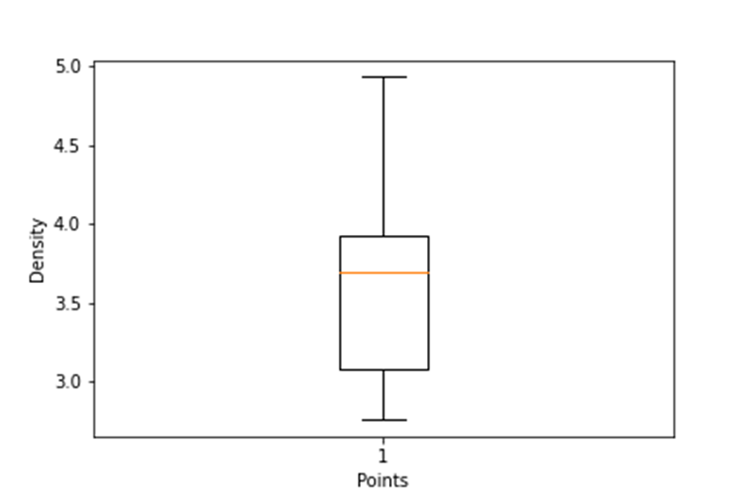

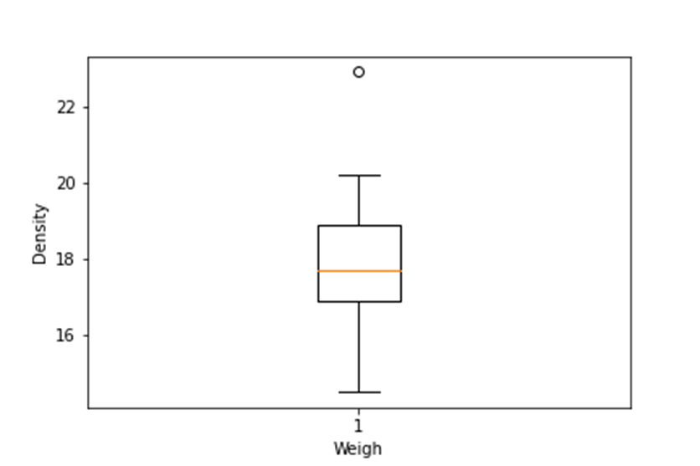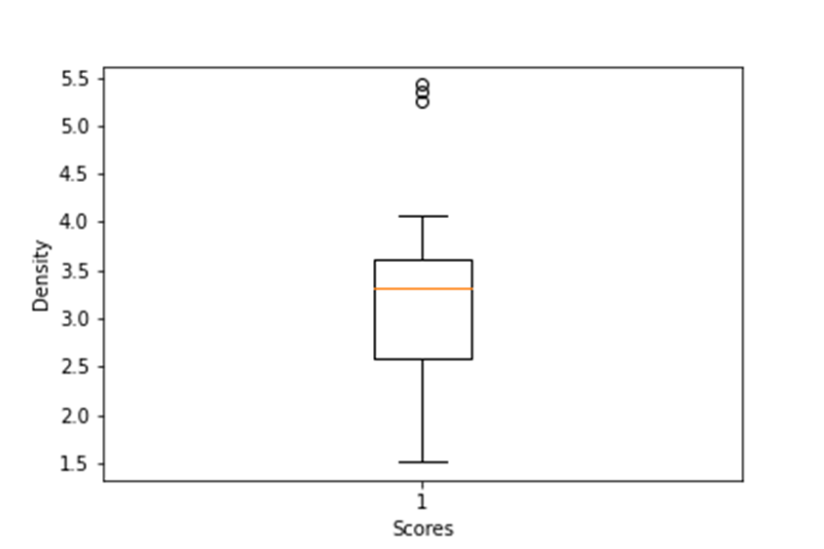

Q8) Calculate Expected Value for the problem below

1. The weights (X) of patients at a clinic (in pounds), are

108, 110, 123, 134, 135, 145, 167, 187, 199

Assume one of the patients is chosen at random. What is the Expected Value of the Weight of that patient?

Ans=

Expected Value = ∑ (probability * Value)

∑ P(x). E(x)

there are 9 patients

Probability of selecting each patient = 1/9

Ex 108, 110, 123, 134, 135, 145, 167, 187, 199

P(x) 1/9 1/9 1/9 1/9 1/9 1/9 1/9 1/9 1/9

Expected Value = (1/9)(108) + (1/9)110 + (1/9)123 + (1/9)134 + (1/9)135 + (1/9)145 + (1/9(167) + (1/9)187 + (1/9)199

= (1/9) ( 108 + 110 + 123 + 134 + 135 + 145 + 167 + 187 + 199)

= (1/9) ( 1308)

= 145.33

Expected Value of the Weight of that patient = 145.33

**Q9) Calculate Skewness, Kurtosis & draw inferences on the following data**

**Cars speed and distance**

**Use Q9_a.csv**

**SP and Weight(WT)**

**Use Q9_b.csv**

**Q10) Draw inferences about the following boxplot & histogram**



Ans=

The histogram peak has right skew and tail is on right .

Mean> median.

We have outliers on the higher side.



Ans= The boxplot has outliers on the maximum side.

**Q11)** Suppose we want to estimate the average weight of an adult male in Mexico. We draw a random sample of 2,000 men from a population of 3,000,000 men and weigh them. We find that the average person in our sample weighs 200 pounds, and the standard deviation of the sample is 30 pounds. Calculate 94%,98%,96% confidence interval?

**Q12)** Below are the scores obtained by a student in tests

**34,36,36,38,38,39,39,40,40,41,41,41,41,42,42,45,49,56**

1. Find mean, median, variance, standard deviation.
2. What can we say about the student marks?

Q13) What is the nature of skewness when mean, median of data are equal?

Ans= Symmetrical.

Q14) What is the nature of skewness when mean > median ?

Ans= Right skewed.

Q15) What is the nature of skewness when median > mean?

Ans= Left Skewed.

Q16) What does positive kurtosis value indicates for a data ?

Ans= Data Normally distributed and Kurtosis Value is 0.

Q17) What does negative kurtosis value indicates for a data?

Ans= Data Lighter tail And Flatter peaks than Normal disrtibution

Q18) Answer the below questions using the below boxplot visualization.



What can we say about the distribution of the data?

Ans= Boxplot is not normally Distributed and the median is towards the higher Values.

What is nature of skewness of the data?

Ans= The data is Left skewed and the whisker range of minimum value is greater than maximum.

What will be the IQR of the data (approximately)?

Ans= The Inter Quantile Range = Q3 Upper quartile – Q1 Lower quartile

=18-10

=8

Q19) Comment on the below Boxplot visualizations?



Draw an Inference from the distribution of data for Boxplot 1 with respect Boxplot 2.

Ans= First there is no outliers. Second both the box plot shares the same median that is approximately in range bet ween 275 to 250 and they are normally distributed with zero to no skewness neither at the minimum or maximum whisker range.

20) Calculate probability from the given dataset for the below cases

Data _set: Cars.csv

Calculate the probability of MPG of Cars for the below cases.

MPG <- Cars$MPG

* 1. P(MPG>38)
  2. P(MPG<40)

c. P (20<MPG<50)

Q 21) Check whether the data follows normal distribution

1. Check whether the MPG of Cars follows Normal Distribution

Dataset: Cars.csv

Ans= MPG of cars follows normal distribution.

1. Check Whether the Adipose Tissue (AT) and Waist Circumference(Waist) from wc-at data set follows Normal Distribution

Dataset: wc-at.csv

Ans= The Adipose Tissue (AT) And Waist Circumference (waist) Does not follow normal distribution.

Q 22) Calculate the Z scores of 90% confidence interval,94% confidence interval, 60% confidence interval

Q 23) Calculate the t scores of 95% confidence interval, 96% confidence interval, 99% confidence interval for sample size of 25

Q 24**)** A Government company claims that an average light bulb lasts 270 days. A researcher randomly selects 18 bulbs for testing. The sampled bulbs last an average of 260 days, with a standard deviation of 90 days. If the CEO's claim were true, what is the probability that 18 randomly selected bulbs would have an average life of no more than 260 days

Hint:

rcode 🡪 pt(tscore,df)

df 🡪 degrees of freedom